Facilities of Department of Education
LibraryFacilities
The department has a library having 422 printed volumes including text books, reference books, magazines etc. It is required of every student to use the library resources for their academic growth. Library books must be returned within 15 days of the date of issue.
Book bank facility is also allowed for needy students. Books are issued for whole academic session. It will have to return the books just after the completion of the examination. Previous years question papers are available in the departmental library.
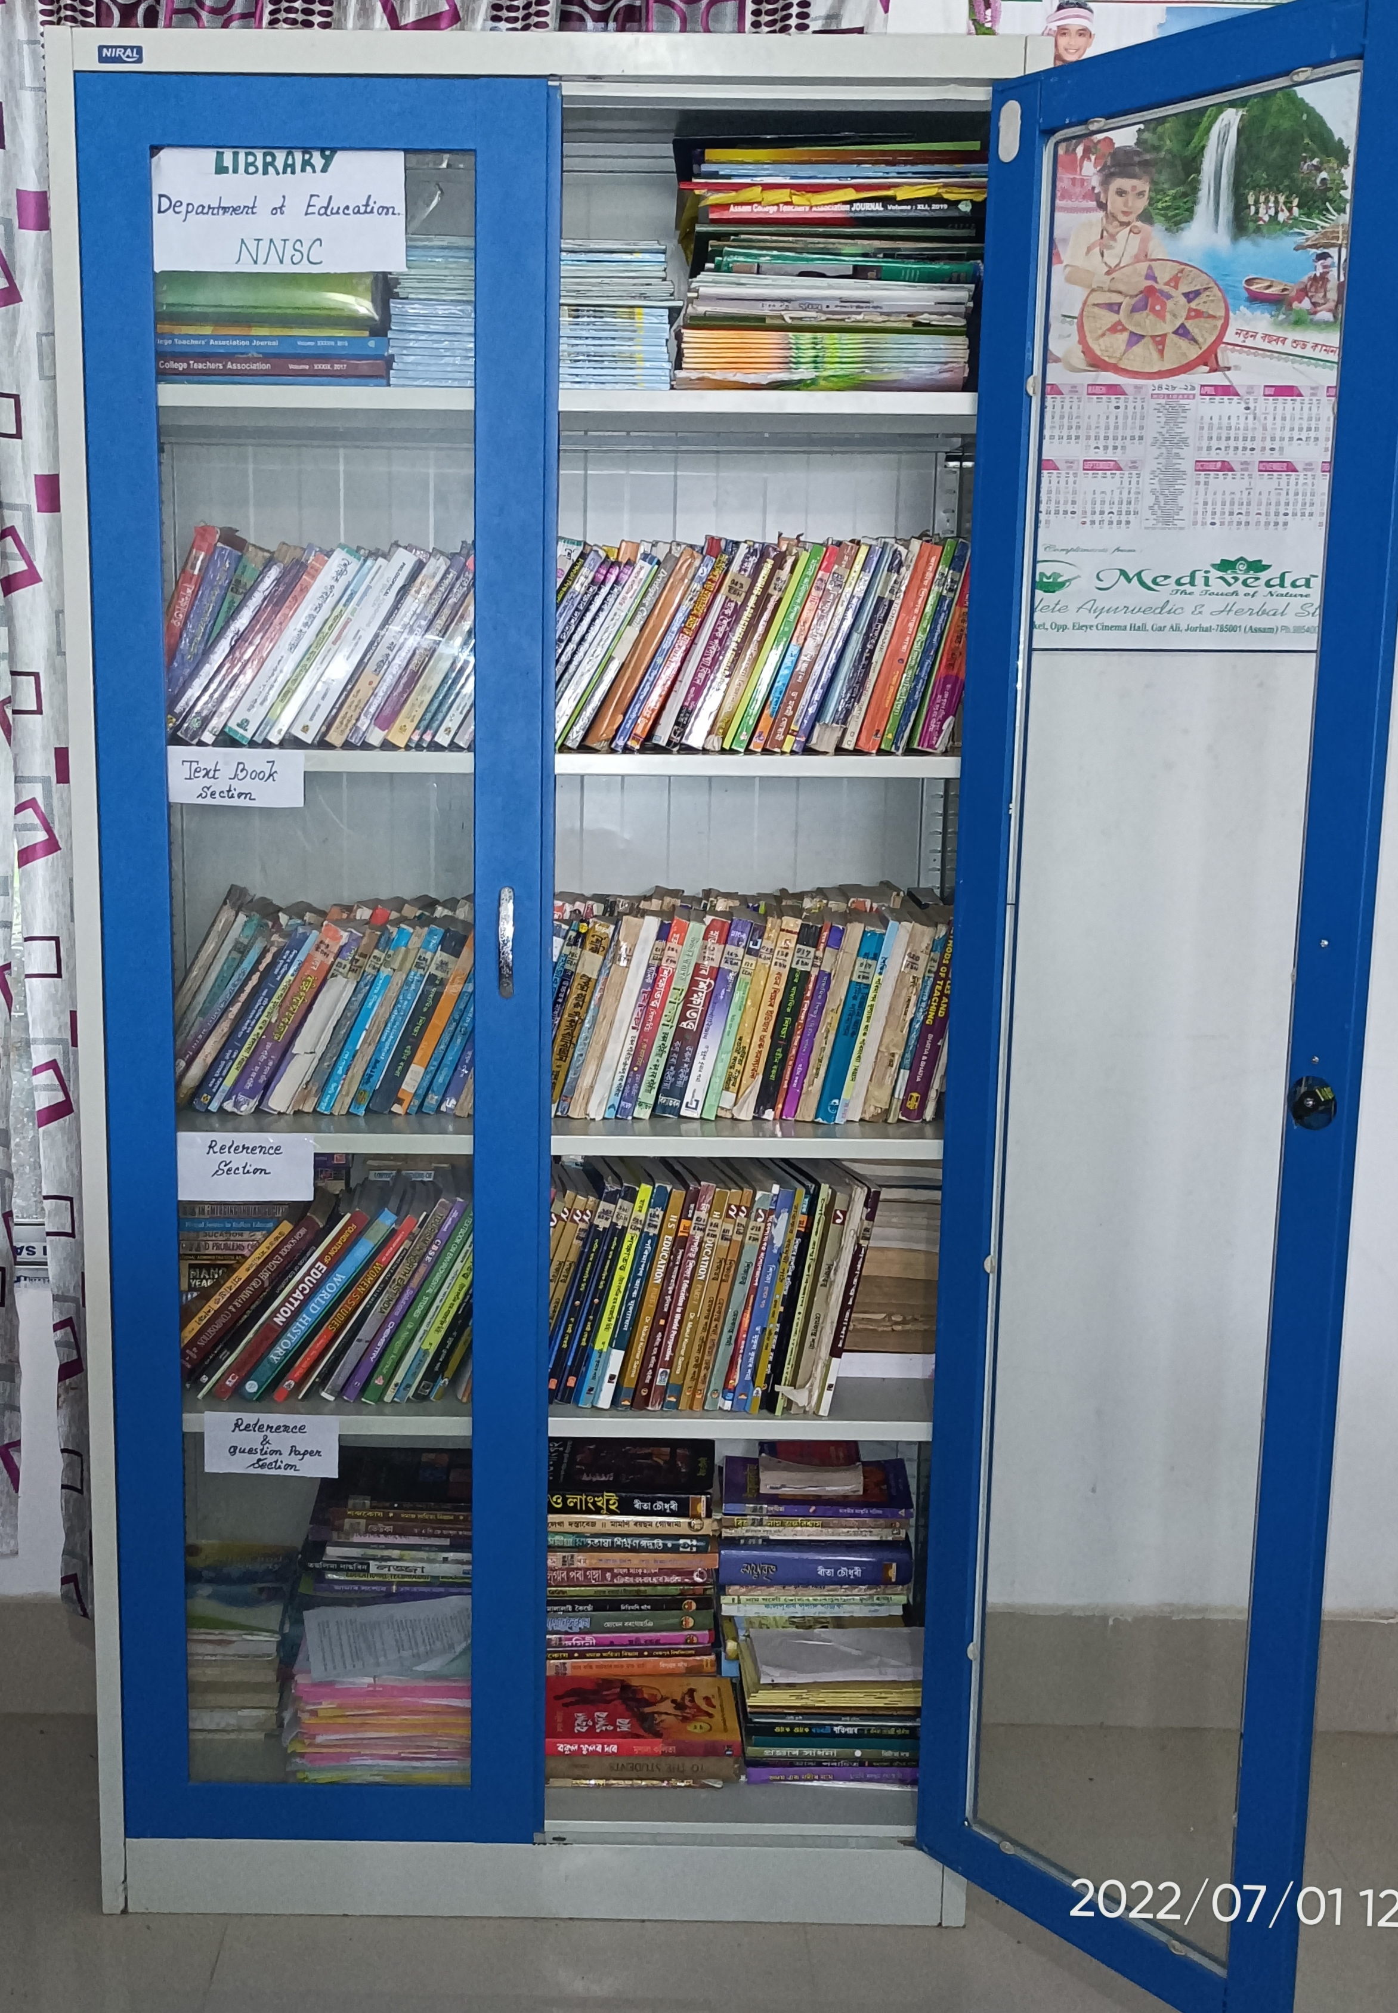
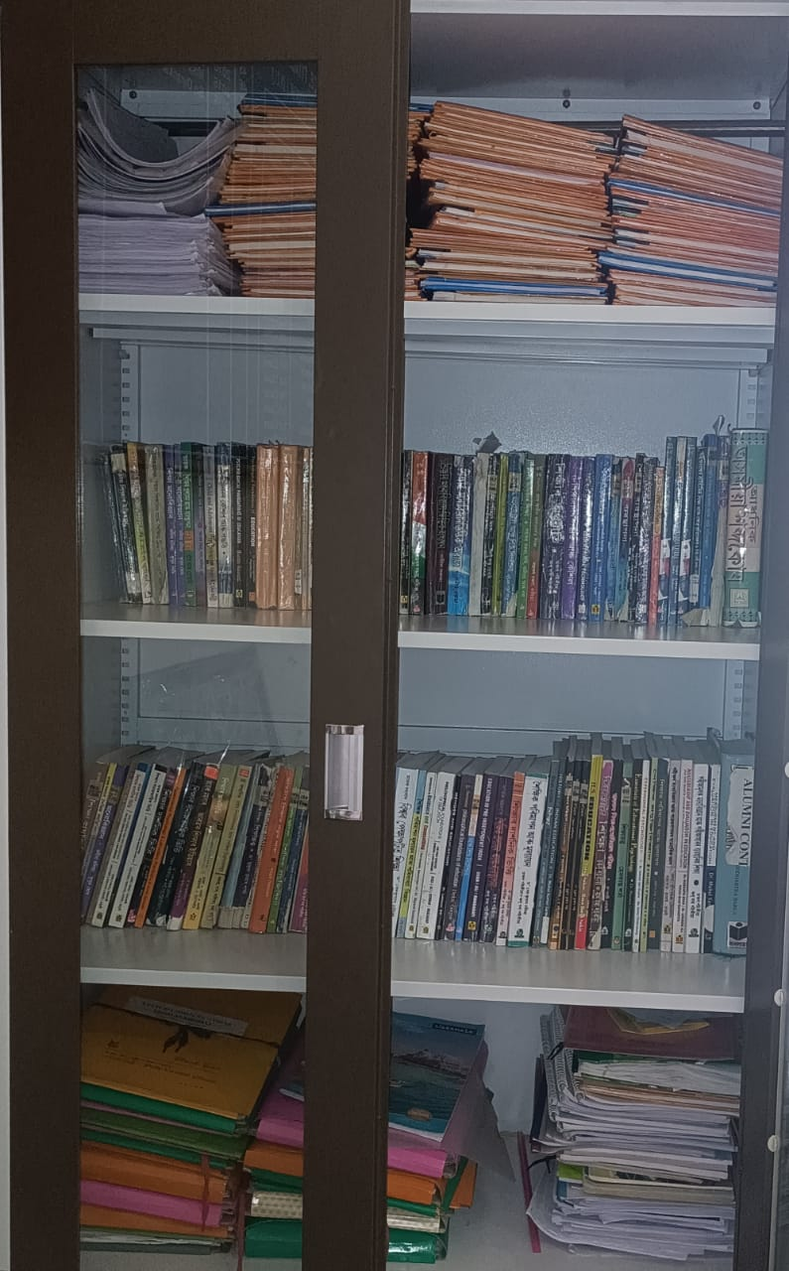
PROJECT & FIELD REPORTS

P
TEXT BOOKS

